**

Mohammad Ali Jinnah University

Chartered by Government of Sindh - Recognized by HEC

Quiz 3

**Subject**: DBMS Lab

**Section**: BM

**Teacher**: Rimsha Javed

**Muhamad Fahad** (FA19-BSSE-0014)

(FA19BSSE0014@maju.edu.pk)

Quiz 3

**Problem#1**

**MobileZone is a trendy mobile store based in Karachi, Pakistan. It purchases mobiles from manufacturers, stocks them in its store, and sells them for profits. MobileZone maintains the details of all branded mobile devices in a SQL Server database. To speed up the day-to-day transactions related to the database, it has been decided to use SQL Server triggers for commonly performed tasks. Table 1.1 describes the Mobile details.**

1. **Start with creating the table Mobiles. The structure of the table is described in Table 1. Add at least five records to the table. Ensure that the value of the column QtyOnHand is more than 20 for each of the mobiles.**

create table Mobiles(

ProductCode Varchar(5) primary key,

BrandName Varchar(30),

Manufacturer Varchar(40),

UnitPrice Money,

QtyOnHand int CHECK (QtyOnHand>20)

);

insert into Mobiles values('A511','Apple Inc','Foxconn','25','21');

insert into Mobiles values('M254','Motorola','Lenovo Motorola','38','50')

insert into Mobiles values('AX50','Tecno','Transsion Holdings','95','42');

insert into Mobiles values('S427','Samsung Electronics Co','Samsung','36','32');

insert into Mobiles values('9C75','Huawei','Huawei Co','22','28');

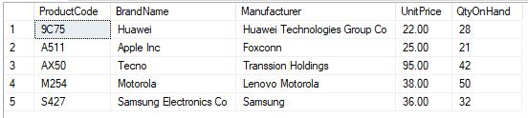

1. **Write statements to create an update the trigger named MobilePrice that will increment the UnitPrice by 1000 for all the mobiles.**

CREATE TRIGGER MobilePrice

ON Mobiles

AFTER update

AS

BEGIN

update Mobiles set UnitPrice+=1000

END;

insert into Mobiles values('MO131','Motorola','Motorola','22','28',2021)

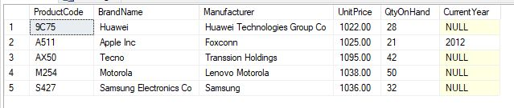

1. **Write statements to create an insert trigger named NewMobile that will insert the latest models of mobiles introduced by the company for the current year.**

--------------------Task 3

alter table Mobiles

add CurrentYear int

update Mobiles set CurrentYear = 2012 where ProductCode = 'A511';

update Mobiles set CurrentYear = 2015 where ProductCode = 'M254';

update Mobiles set CurrentYear = 2010 where ProductCode = 'AX50';

update Mobiles set CurrentYear = 2018 where ProductCode = 'S427';

update Mobiles set CurrentYear = 2021 where ProductCode = '9C75';

insert into Mobiles values('MO131','Motorola','Motorola','22','28',2021)

Select * from Mobiles

CREATE TRIGGER NewMobile

on Mobiles

instead of insert

as

begin

if((select i.CurrentYear from inserted i) = Year(GetDate()))

begin

insert into Mobiles select * from inserted

end

else

begin

RAISERROR ('The latest models of mobiles.' ,10,1)

end

end

insert into Mobiles values('7S82','INFINIX','INFINIX','55','100',2021)



1. **Write statements to create a stored procedure DecreaseQuantity that will decrease the quantity on hand of specified brands by 25. The brand name should be supplied as input.**

---------------Task 4

CREATE procedure DecreaseQuantity(@BrandName varchar(30))

as

begin

update Mobiles set QtyOnHand -= 25

where BrandName = @BrandName

end

1. **Execute the stored procedure DecreaseQuantity.**

---------------------Task 5

execute DecreaseQuantity 'INFINIX'

